Use Case Specification: Allocate Resources

Authors: Ovidiu Pop (Ovidiu.Pop@cs.utcluj.ro)
Document Number: UC02
Version: 0.0.4

Record of Processing
No. | Version | Date | Status | Who | Description
1 | 0.0.1 | 2017-01-23 | First draft. |  | First draft.
2 | 0.0.2 | 2017-01.26 | Updated. |  | Updated.
3 | 0.0.3 | 2017-01-26 | Updated.
4 | 0.0.4 | 2017-02-04 | Updated |  | Updated preconditions for project states
5
6
7

Record of Approval
No. | Version | Date | Who | Description
1 | … | … | …
2
3
4
5
6
7

Recipients of Document
No. | Version | Date of Distribution | Recipients
1 | … | …
2
3
4
5
6
7
Table of Contents
1 Allocate Resources 5
1.1 Brief Description 5
1.2 Primary Actor 5
1.3 Stakeholders and Interests 5
1.4 References 5
1.4.1 HR.Requirements Glossary. 5
1.4.2HR.UC.Search Resources. 5
1.4.3 HR.UC.Deallocate Resource. 5
1.4.4 HR.Business Rules and Entities. 5
2 Flow of Events 6
2.1 Basic Flow 7
2.1.1 The actor creates a new scenario or selects an already existing one and opens it for edit operation. 7
2.1.2 The system will display the scenario attributes. 7
2.1.3 The actor will set/change the scenario attributes. 7
2.1.4 The actor searches for resources; see extension point 6.1 7
2.1.5 The actor selects a resource from the search results and then selects the allocate action. 7
2.1.6 The actor checks if all the resources are available (free) and does one of the steps 2.1.6.1 or 2.1.6.2. 7
2.2 Alternative Flows 7
2.2.1 Abort allocation 7
2.2.2 Deallocate a resource. 7
2.2.3 Create operation failed 8
2.2.4 Operation failed 8
3 Special Requirements 8
4 Preconditions 8
4.1 The actor is authenticated and authorized for this use case. 8
4.2 An allocation scenario is opened through a New or Edit operation. 8
4.3 The project’s state must be ‘Project Approved’ or ‘Project in Progress’ in order for resource allocation to be peformed. Resource allocation cannot be performed on projects in states: ‘Project not started’, ‘Project completed’, ‘Project Canceled’, ‘Project Erased’, ‘Project Archived’. For more information see: 1.4.4 8
5 Postconditions 8
5.1 Scenario entities should remain in a consistent state if the Save/Commit operation has ended with success. 8
5.2 Scenario entities should not suffer any changes if the Save/Commit operation has not ended with success. 8
6 Extension Points 8
6.1 Search for resources. 8
6.2 Deallocate resource. 8
7 Technology and Data Variation List 8
8 Open Questions 9

Allocate Resources

- Allocate Resources
  - Brief Description
The purpose of this document is to capture the flow of events that an actor must follow in order to manage the resource allocation in a custom scenario.
  - Primary Actor
Resource Allocator.
  - Stakeholders and Interests
Resource Allocator – interested in having a user friendly page for the process of allocating the best suitable resources for a project, in terms of occupation time, category, level, skill and skill rank. The UI must be as simple as possible. Also, response times must be short.
  - References

HR Requirements Glossary.

HR UC.Search Resources.

HR.UC.Deallocate Resource.

HR Business Rules and Entities.

- Flow of Events

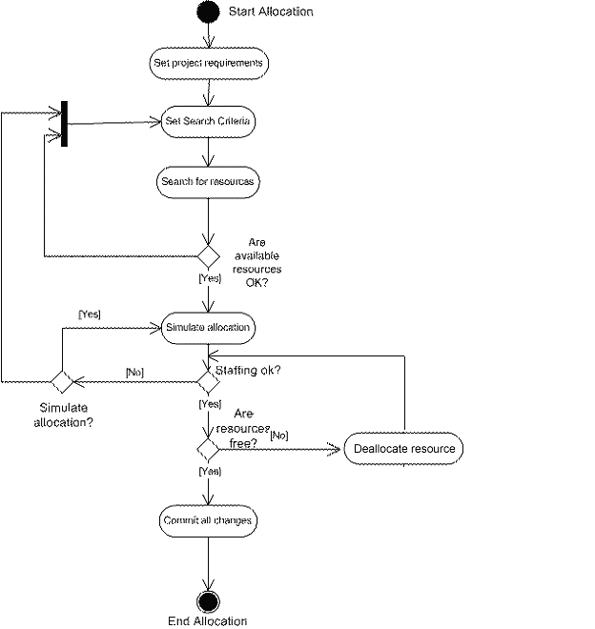

  - Basic Flow

Use-Case Start
This use case starts when the actor wants to create/modify a specific scenario.

The actor creates a new scenario or selects an already existing one and opens it for edit operation.

The system will display the scenario attributes.

The actor will set/change the scenario attributes.

The actor searches for resources; see extension point 6.1

The actor selects a resource from the search results and then selects the allocate action.

The actor checks if all the resources are available (free) and does one of the steps 2.1.6.1 or 2.1.6.2.

If not all the resources are available, the actor does one of the steps: 2.1.6.1.1 (deallocate a resource) or 2.1.6.1.2 (ends allocation operation).

Deallocate a resource (see alternative flow 2.2.2)

The actor closes the allocation operation through a Save (save the current scenario) operation.

If all the resources are available, the actor does one of the steps: 2.1.6.2.1 (save current scenario) or 2.1.6.2.2 (commit current scenario)

The actor closes the allocation operation through a Save (save the current scenario) operation.

The actor closes the allocation operation through a Commit (saves a project with current allocation resources) operation.

Use-Case End
The actor end the allocation operation 2.1.6.2.2, 2.2.1

  - Alternative Flows

Abort allocation
This flow can occur in one of the following steps: 2.1.3, 2.1.4, 2.1.5 or 2.1.6.

The actor selects the Abort (cancel the allocation) operation and leaves the resources allocation page.

The system remains unchanged.

Deallocate a resource.
This flow can occur in one of the following steps: 2.1.6.1.1

The actor set the deallocation prerequisites.

The actor starts the Deallocate Resources UC (see extension point 6.2).

The actor returns to the step 2.1.6 (checks if all resources are available).

Create operation failed

The create operation will fail when the actor will try to create a scenario with a name already existing in the system (the names of all the scenarios stored in the system must be unique).

The system will display a message. No changes are made in system. This flow can occur in 2.1.6.2.2

Operation failed

The operation chosen by the actor failed from different reasons.

The system displays a user friendly message. No changes are made in system.

Special Requirements
NAN
- Preconditions
  - The actor is authenticated and authorized for this use case.
  - An allocation scenario is opened through a New or Edit operation.
  - The project’s state must be ‘Project Approved’ or ‘Project in Progress’ in order for resource allocation to be performed on a project. Resource allocation on project cannot be performed on projects in states: ‘Project not started’, ‘Project completed’, ‘Project Canceled’, ‘Project Erased’, ‘Project Archived’. For more information see: 1.4.4
  - The project’s state must be ‘Project not started’, ‘Project Approved’ or ‘Project in Progress’ in order for a resource to be allocated in a scenario. Resource allocation in scenario cannot be performed when scenario’s project in one of the states: ‘Project completed’, ‘Project Canceled’, ‘Project Erased’, ‘Project Archived’. For more information see: 1.4.4
- Postconditions

Project / Scenario entities should remain in a consistent state if the Save/Commit operation has ended with success.

Project / Scenario entities should not suffer any changes if the Save/Commit operation has not ended with success.

Project resource allocation should not suffer any change if only save (not commit) operations were executed with success on scenarios.

- Extension Points

Search for resources.
See “HR.UC.Search Resources” file, which describes the Use Case for resource searching.

Deallocate resource.
See “HR.UC.Deallocate Resource” file, which describes the Use Case for deallocating a resource from a specified project.
- Technology and Data Variation List
NAN
- Open Questions
NAN

